
Formula 1 Race Intelligence
Dashboard Analysis Report
Project Report – Data Visualisation with Tableau

1. INTRODUCTION

1.1 Project Overview
Formula 1 produces a very large amount of race data, but raw tables make it hard to see who is performing, which strategies work and where failures occur. This project builds a Formula 1 Race Intelligence Dashboard in Tableau using 6,464 race records across 17 seasons. It presents driver performance, team championship trajectories, tyre compound strategies, circuit-level race participation, driver reliability and DNF analysis, and global podium achievements as interactive visualisations, combined into one dashboard and a Tableau Story.
The dashboard is designed for three users: a team performance strategist who benchmarks a mid-tier team against Red Bull Racing and Mercedes, a motorsport broadcast analyst who needs quick leaderboards and podium graphics, and an FIA technical regulation analyst who studies DNF patterns and driver reliability.

1.2 Purpose
- Turn historical F1 race records into clear, interactive visual insights.
- Help strategists benchmark championship points and understand how tyre compounds affect race outcomes.
- Help broadcasters and journalists quickly retrieve leaderboards, host-country and podium statistics.
- Help regulators identify DNF and reliability patterns to support evidence-based technical regulation recommendations.

2. IDEATION PHASE

2.1 Problem Statement
Team strategists, broadcast analysts and regulatory analysts need quick answers from F1 race data, but the data is spread across many seasons, drivers, teams and circuits in tabular form. Without visual analysis they cannot easily compare team trajectories, judge tyre strategies, find the strongest talent pools or spot recurring failure types.
Persona | I am… | I'm trying to… | But… | Because… | Which makes me feel…
Performance strategist | a senior strategist at a mid-tier F1 team | benchmark my team against Red Bull Racing and Mercedes and plan tyre strategy and recruitment | season-by-season data is hard to compare | results are in separate tables | uncertain about where to focus
Broadcast analyst | a motorsport data journalist | get leaderboards, host countries and podium data quickly for live content | I lose time searching and building charts | no single visual source exists | under time pressure
FIA regulation analyst | a technical regulation compliance analyst | find DNF causes and reliability trends across 17 seasons | failure types are not easy to compare by team or circuit | data is not summarised | unable to support recommendations with evidence

2.2 Empathy Map Canvas
Primary user: the F1 team performance strategist.
SAYS  • “How do we compare with Red Bull and Mercedes over the seasons?”  • “Which tyre compound gives the best results at this circuit?” | THINKS  • Data-driven decisions will help us climb the Constructors' standings.  • Recruitment should target the strongest talent pools.
DOES  • Compares points trajectories and race results.  • Reviews tyre compound use and reliability before planning the season. | FEELS  • Pressure to improve results with a limited budget.  • Frustrated by scattered data; confident when insights are clear.

2.3 Brainstorming
The team listed possible views and selected those that answer the scenario questions most directly.
Idea | Question it answers | Selected
Driver Performance Leaderboard | Who has scored the most points? | Yes
Team Championship Trajectory | How does our team compare with Red Bull and Mercedes? | Yes
Tyre Compound Strategy chart | Which compound works best, and where? | Yes
Grand Prix host-country map and circuit participation | Which countries and circuits host the most races? | Yes
Podium achievements and nationality talent pools | Which drivers, teams and countries win podiums? | Yes
Driver Reliability / DNF stacked bar | Which failures are most common, and where? | Yes
Live race prediction model | Who is likely to win next race? | Future scope

3. REQUIREMENT ANALYSIS

3.1 Customer Journey Map
Stage | User action | Touchpoint | Experience / need | Opportunity
Awareness | Needs insight before a season, broadcast or review | Project link / Tableau Public | Wants a quick overview | Clear KPI header
Access | Opens the dashboard | Tableau Public dashboard | Wants it to load fast and be easy to read | Simple layout
Explore | Applies filters (season, team, driver, circuit, tyre) | Interactive filters | Wants answers without writing queries | Filters apply to all views
Analyse | Compares trajectories, tyres, podiums and DNFs | Six linked views, tooltips | Wants to spot patterns | Highlights and drill-down
Decide / Share | Uses insights for strategy, graphics or recommendations | Story, screenshots | Wants evidence to present | Tableau Story with observations

3.2 Solution Requirements
Type | Requirement
Functional | Load and clean the F1 race dataset (6,464 records, 17 seasons).
Functional | Show driver leaderboard, team trajectory, tyre strategy, circuit participation, podiums and DNF/reliability views.
Functional | Provide filters for season, team, driver, circuit / country, tyre compound and DNF type.
Functional | Combine the views into an interactive dashboard and a Tableau Story, and publish to Tableau Public.
Non-functional | Dashboard should load quickly and be readable on standard screens.
Non-functional | Consistent colours, labels and tooltips; calculated fields documented.
Non-functional | Data accuracy: DNF and reliability definitions agreed and applied consistently.

3.3 Data Flow Diagram
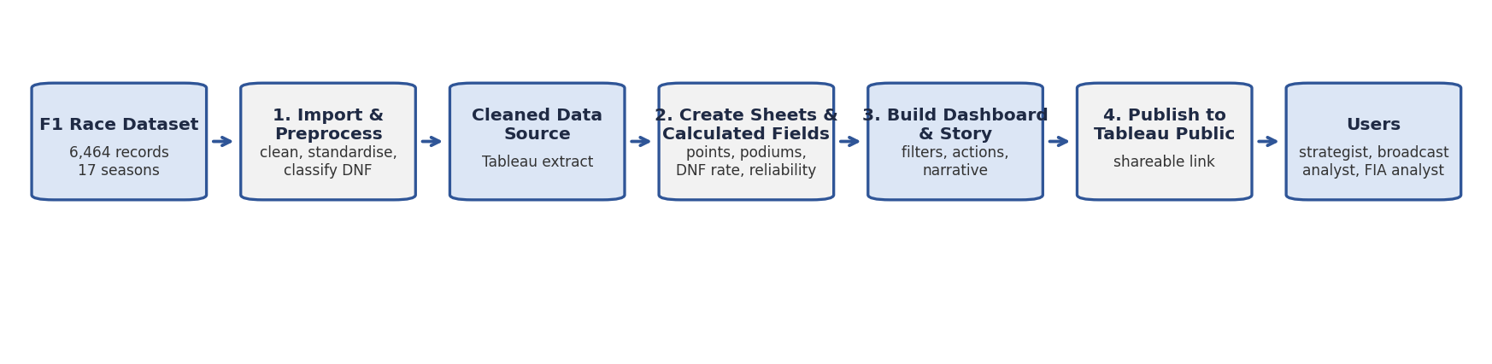
Figure 1: Data flow from the F1 race dataset through preparation, visualisation and publishing to the end users.

3.4 Technology Stack
Component | Technology
Visualisation and dashboards | Tableau Desktop
Publishing | Tableau Public
Data source | F1 race-results dataset (CSV / Excel), 6,464 records across 17 seasons
Calculations | Tableau calculated fields (points, podium flag, DNF flag, DNF rate, reliability score)
Documentation and collaboration | Microsoft Word, Google Drive / GitHub, Google Meet

4. PROJECT DESIGN

4.1 Problem Solution Fit
Problem | Solution
Data is spread across seasons, drivers and teams in tables. | A single dashboard linking six views with shared filters.
Hard to benchmark a team against Red Bull Racing and Mercedes. | Team Championship Trajectory line chart.
Unclear which tyre compounds work at which circuits. | Tyre Compound Strategy chart filterable by circuit and season.
Broadcasters need quick leaderboards, host-country and podium data. | Driver leaderboard, host-country map and podium charts.
Regulators cannot easily see DNF patterns. | Driver Reliability Analysis stacked bar chart by failure type, team and circuit.

4.2 Proposed Solution
The solution is an interactive Tableau dashboard and story with six visualisations built on the cleaned race dataset: Driver Performance Leaderboard, Team Championship Trajectory, Tyre Compound Strategy, Circuit and Grand Prix Host Map, Podium Achievements, and Driver Reliability / DNF Analysis. Shared filters let each user answer their own scenario questions, and the Tableau Story presents the findings in a logical order with recommendations.

4.3 Solution Architecture
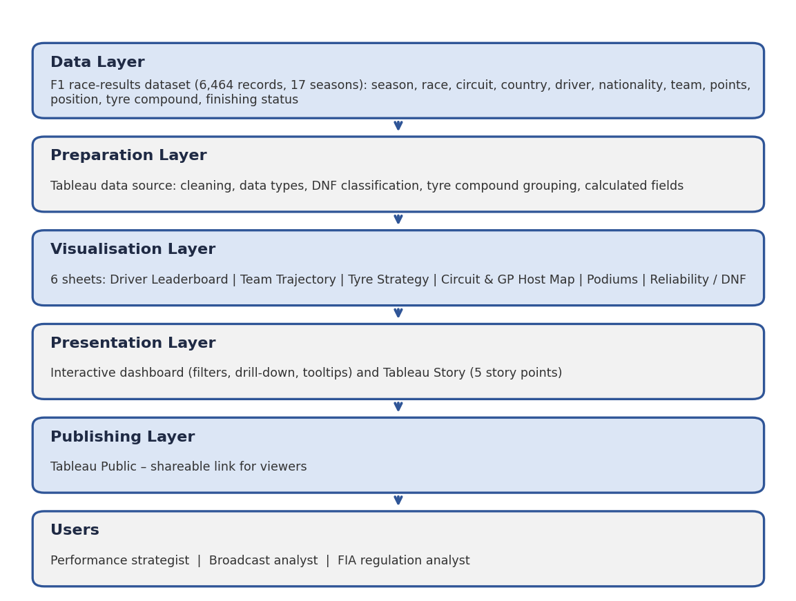
Figure 2: Layered solution architecture.

5. PROJECT PLANNING & SCHEDULING

5.1 Project Planning
Phase | Activities | Output | Timeline
1. Ideation | Choose topic, define problem, personas, scenarios and business questions | Problem statement, questions list
2. Data preparation | Load dataset, clean data, create calculated fields | Prepared Tableau data source
3. Visualisation | Build the six sheets | Visualisations
4. Dashboard and Story | Combine sheets, add filters, build story and observations | Dashboard, Story
5. Testing and publishing | Performance and functional checks; publish to Tableau Public | Public links
6. Documentation and demo | Final report, demo planning, rehearsal | Report, demo

6. FUNCTIONAL AND PERFORMANCE TESTING

6.1 Performance Testing
S.No | Parameter | Values / Screenshot
1 | Data Rendered | 6,464 race records across 17 seasons loaded into Tableau
2 | Data Preprocessing | Nulls and duplicates checked; names standardised; data types set; DNF and tyre compound classified
3 | Utilization of Filters | Season, Team, Driver, Circuit / Country, Tyre Compound, DNF type
4 | Calculation fields Used | Total Points, Podium Flag, DNF Flag, DNF Rate, Driver Reliability Score, Average Points per Race
5 | Dashboard design | 6 visualisations
6 | Story Design | 6 visualisations across 5 story points

Functional checks: each filter updates all six sheets; tooltips display correct values; the dashboard and story open correctly from the published links.

7. RESULTS

7.1 Output Screenshots
Driver Performance Leaderboard

Team Championship Trajectory

Tyre Compound Strategy

Circuit and Grand Prix Host Map

Podium Achievements

Driver Reliability / DNF Analysis

F1 Race Intelligence Dashboard

Tableau Story

8. ADVANTAGES & DISADVANTAGES
Advantages | Disadvantages
Single interactive view of drivers, teams, tyres, circuits, podiums and reliability. | Data is historical; no live race-weekend feed.
Serves three different user groups with the same dashboard. | Race-record level only; no lap-by-lap or telemetry data.
Filters allow quick what-if exploration without technical skill. | Tableau Public has no user roles or access control.
Story format makes findings easy to present. | Insights depend on the quality and coverage of the dataset.

9. CONCLUSION
The Formula 1 Race Intelligence Dashboard turns 6,464 race records across 17 seasons into clear visual insights. It helps strategists benchmark their team and plan tyre and recruitment strategy, gives broadcasters fast access to leaderboards and podium data, and gives regulators evidence on DNF and reliability patterns. The project shows how Tableau dashboards and stories can support data-driven decisions in motorsport.

10. FUTURE SCOPE
- Add a live data feed and automatic refresh for race weekends.
- Include lap-by-lap, pit-stop and telemetry data for deeper tyre strategy analysis.
- Add predictive models for podium probability and DNF risk.
- Deploy on Tableau Cloud with role-based access and mobile-friendly layouts.

11. APPENDIX
Source Code (if any) | Not applicable – built in Tableau (workbook file: [workbook name .twbx])
Dataset Link | https://docs.google.com/spreadsheets/d/1ypeO8iY3Azg8fQKGIjY49zER7L-dFpcn/edit?usp=sharing&ouid=115115971864204615237&rtpof=true&sd=true
GitHub Link | https://github.com/kartikupdadhyay16/FORMULA-1-Race-Intelligence-Dashboard-Analysis-Report-
Project Demo Link | [Paste demo video / Tableau Public link]

